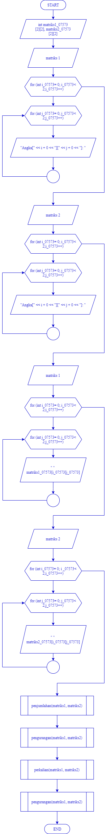FLOWCHART

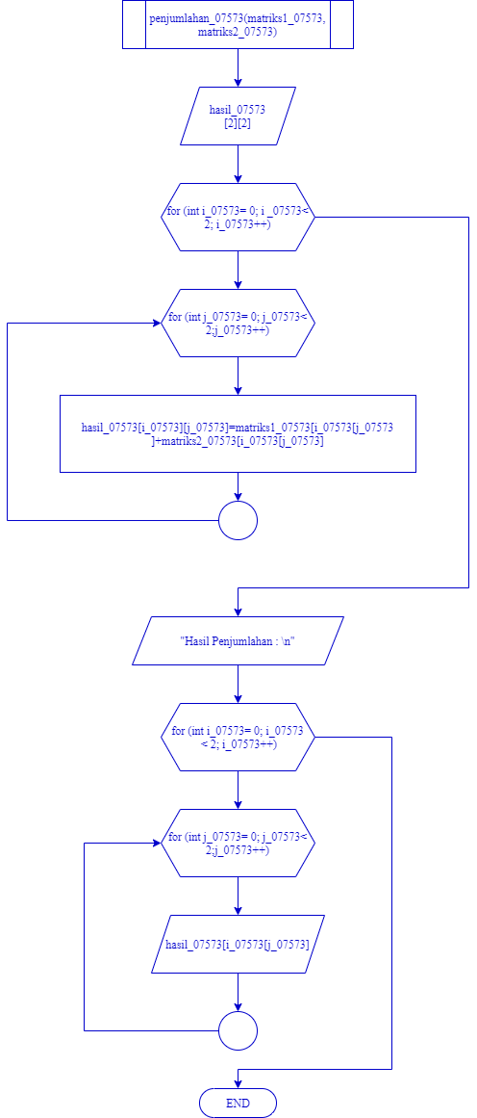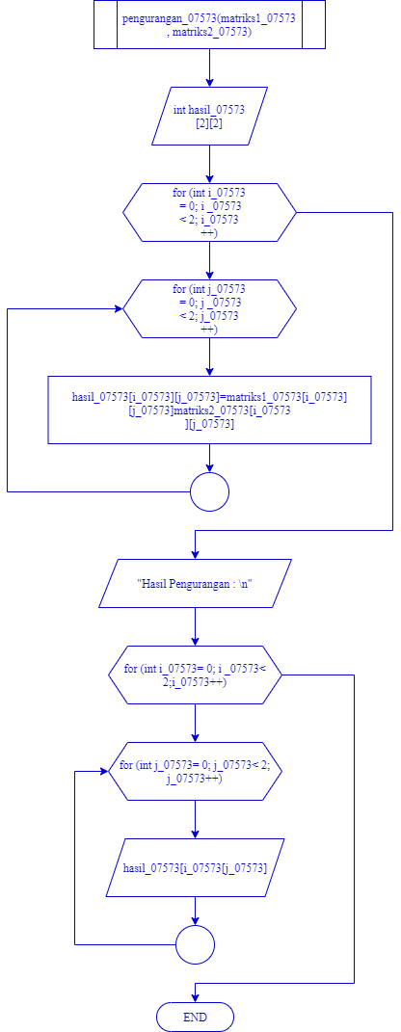

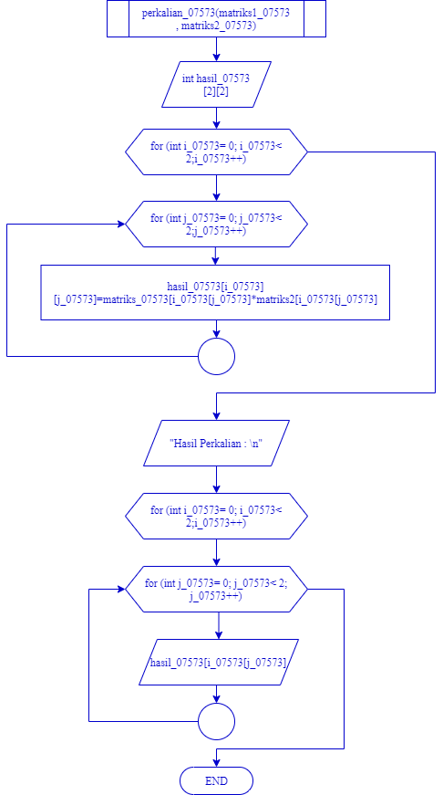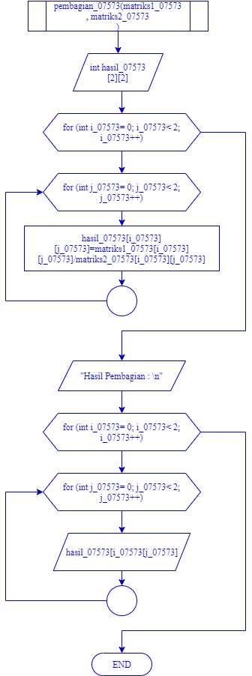

SOURCE CODE

#ifndef nanda_h_include

#define nanda_h_include

#include <iostream>

using namespace std;

void penjumlahan(int matriks1_07573[2][2], int matriks2[2][2]){

int hasil_07573_07573[2][2];

for (int i_07573 = 0; i_07573 < 2; i_07573++){

for (int j_07573 = 0; j_07573 < 2; j_07573++){

hasil_07573_07573[i_07573][j_07573]=matriks1_07573[i_07573][j_07573]+matriks2[i_07573][j_07573];

}

}

cout << "hasil_07573 Penjumlahan : \n";

for (int i_07573 = 0; i_07573 < 2; i_07573++){

for (int j_07573 = 0; j_07573 < 2; j_07573++){

cout << " " << hasil_07573_07573[i_07573][j_07573];

}

cout << "\n";

}

}

void pengurangan(int matriks1_07573[2][2], int matriks2[2][2]){

int hasil_07573_07573[2][2];

for (int i_07573 = 0; i_07573 < 2; i_07573++){

for (int j_07573 = 0; j_07573 < 2; j_07573++){

hasil_07573_07573[i_07573][j_07573]=matriks1_07573[i_07573][j_07573]-matriks2[i_07573][j_07573];

}

}

cout << "hasil_07573 Pengurangan : \n";

for (int i_07573 = 0; i_07573 < 2; i_07573++){

for (int j_07573 = 0; j_07573 < 2; j_07573++){

cout << " " << hasil_07573[i_07573][j_07573];

}

cout << "\n";

}

}

void perkalian(int matriks1_07573[3][3], int matriks2[3][3]){

int hasil_07573[3][3];

for (int i_07573 = 0; i_07573 < 2; i_07573++){

for (int j_07573 = 0; j_07573 < 2; j_07573++){

hasil_07573[i_07573][j_07573]=matriks1_07573[i_07573][j_07573]*matriks2[i_07573][j_07573];

}

}

cout << "hasil_07573 Perkalian : \n";

for (int i_07573 = 0; i_07573 < 2; i_07573++){

for (int j_07573 = 0; j_07573 < 2; j_07573++){

cout << " " << hasil_07573[i_07573][j_07573];

}

cout << "\n";

}

}

void pembagian(int matriks1_07573[3][3], int matriks2_07573[2][2]){

int hasil_07573[2][2];

for (int i_07573 = 0; i_07573 < 2; i_07573++){

for (int j_07573 = 0; j_07573 < 2; j_07573++){

hasil_07573[i_07573][j_07573]=matriks1_07573[i_07573][j_07573]/matriks2[i_07573][j_07573];

}

}

cout << "hasil Pembagian : \n";

for (int i_07573 = 0; i_07573 < 2; i_07573++){

for (int j_07573 = 0; j_07573 < 2; j_07573++){

cout << " " << hasil_07573[i_07573][j_07573];

}

cout << "\n";

}

}

int main () {

int matriks1_07573[2][2], matriks2[3][3];

cout << "Matriks Ordo 2" << endl;

// Matriks 1

cout << "Matriks 1\n";

for (int i_07573 = 0; i_07573 < 2; i_07573++){

for (int j_07573 = 0; j_07573 < 2; j_07573++){

cout << "Angka[" << i_07573 + 0 << "][" << j_07573 + 0 << "]: ";

cin >> matriks1_07573[i_07573][j_07573];

}

cout << "\n";

}

// Matriks 2

cout << "Matriks 2\n";

for (int i_07573 = 0; i_07573 < 2; i_07573++){

for (int j_07573 = 0; j_07573 < 2; j_07573++){

cout << "Aangka[" << i_07573 + 0 << "][" << j_07573 + 0 << "]: ";

cin >> matriks2[i_07573][j_07573];

}

cout << "\n";

}

// Cetak isi matriks 1

cout << "Matriks 1\n";

for (int i_07573 = 0; i_07573 < 2; i_07573++){

for (int j_07573 = 0; j_07573 < 2; j_07573++){

cout << " " << matriks1_07573[i_07573][j_07573];

}

cout << "\n";

}

// Cetak isi matriks 2

cout << "Matriks 2\n";

for (int i_07573 = 0; i_07573 < 2; i_07573++){

for (int j_07573 = 0; j_07573 < 2; j_07573++){

cout << " " << matriks2[i_07573][j_07573];

}

cout << "\n";

}

penjumlahan(matriks1_07573, matriks2);

pengurangan(matriks1_07573, matriks2);

perkalian(matriks1_07573, matriks2);

pembagian(matriks1_07573, matriks2);

}

#endif // nanda_h_include

HASIL PROGRAM

